29th May 2019

**YOKOHAMA’s “BluEarth-GT AE51” Coming Factory-Equipped on New MAZDA3**

YOKOHAMA is supplying its “BluEarth-GT AE51” tyres as original equipment (OE) for Mazda Motor Corporation’s new MAZDA3, which went on sale globally on 24th May 2019. The new MAZDA3 is coming factory-equipped with 205/60R16 92V size tyres. “BluEarth-GT AE51” are being fitted on MAZDA3 vehicles sold in all markets except North America.   
  
The “BluEarth-GT AE51” incorporates the basic design and materials technology used in YOKOHAMA’s “environmentally, human, and socially friendly” BluEarth global tyre brand. The tyres’ superior driving, comfort and environmental performance makes them outstanding grand touring tyres. YOKOHAMA is aggressively developing tyres employing its leading-edge “BluEarth” tyre technology, and many of these tyres are now coming factory-equipped on a wide variety of new car models, including the latest-model sedans, SUVs, sports cars, and compact cars.   
  
The MAZDA3 is a strategic global model that delivers Mazda’s “Joy of Driving” to customers around the world. With over six million cumulative units produced, the MAZDA3 has become the main vehicle manufactured at Mazda’s major plants around the world and has been the driving force in enhancing Mazda’s brand name and business performance. Based on a design concept centred on the driver, the new MAZDA3 dramatically enhances basic vehicle performance, making the vehicle’s every movement – from rolling, turning and stopping – feel like second nature to the driver.

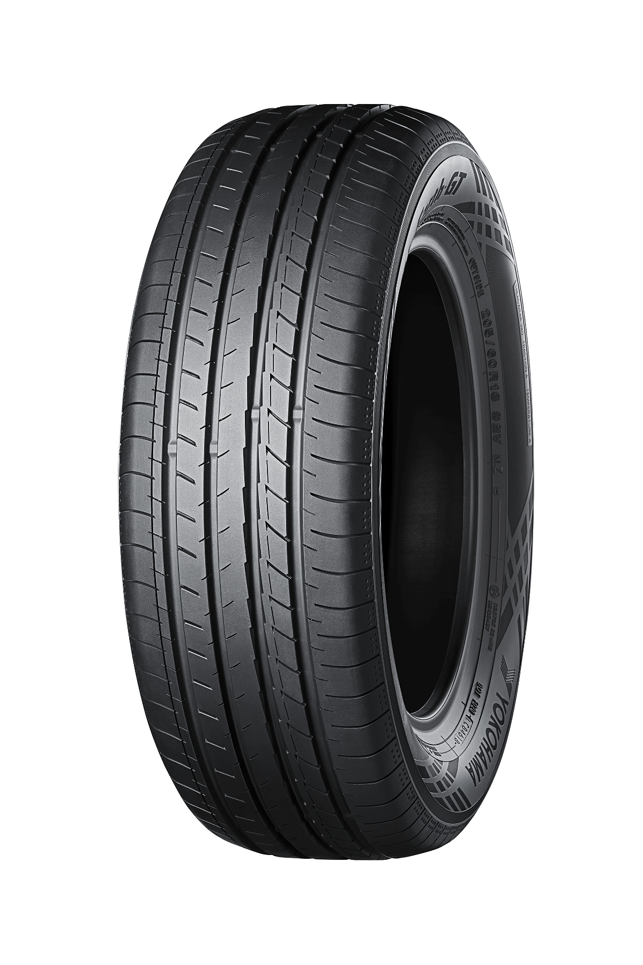

*“BluEarth-GT AE51”*



*New MAZDA3. This photo is used with the permission of Mazda Motor Corporation. Reprint or other usage of this image without prior permission from Mazda Motor is strictly prohibited.*